(date)

(Contact name)
(Contract Address 1)
(Contact Address 2)
(City, State, Zip)

Dear (Contact Name),

(Insured Name) recently worked with me to put a Living Benefits policy in place for (his/herself) and (his/her family).

These policies allow the policyholder to accelerate their life insurance policy’s death benefit and get much-needed money in their hands while they’re still living if they are to suffer a major illness or injury. To ensure that this policy is able to do what it is designed to do, it is critical to designate Emergency Contacts that will serve to alert me if any qualifying triggers occur with regard to (Insured Name)’s health.

(Insured Name) has identified you as a trusted individual to serve as one of (his/her) emergency contacts. The purpose of this letter is to introduce myself as the person that you will need to contact if you become aware that the insured has been stricken with any of the following triggering conditions:

• Heart Attack
• Stroke
• Cancer
• Major Organ Transplant
• Blindness
• Lou Gehrig’s Disease (ALS)

• Kidney Failure
• Aorta Graft Surgery
• Aplastic Anemia
• Cystic Fibrosis
• Heart Valve Replacement
• Motor Neuron Disease

• Sudden Cardiac Arrest
• Paralysis
• Coma
• Severe Burns
• Traumatic Brain Inju
Your job as a designated Emergency Contact is simple: save this letter and my contact information in a safe place. Should (Insured Name) suffer any of the above triggers at any time in the future, please contact me immediately via phone or email so I can utilize (his/her) Living Benefits policy to render the financial protection this policy provides as soon as possible.

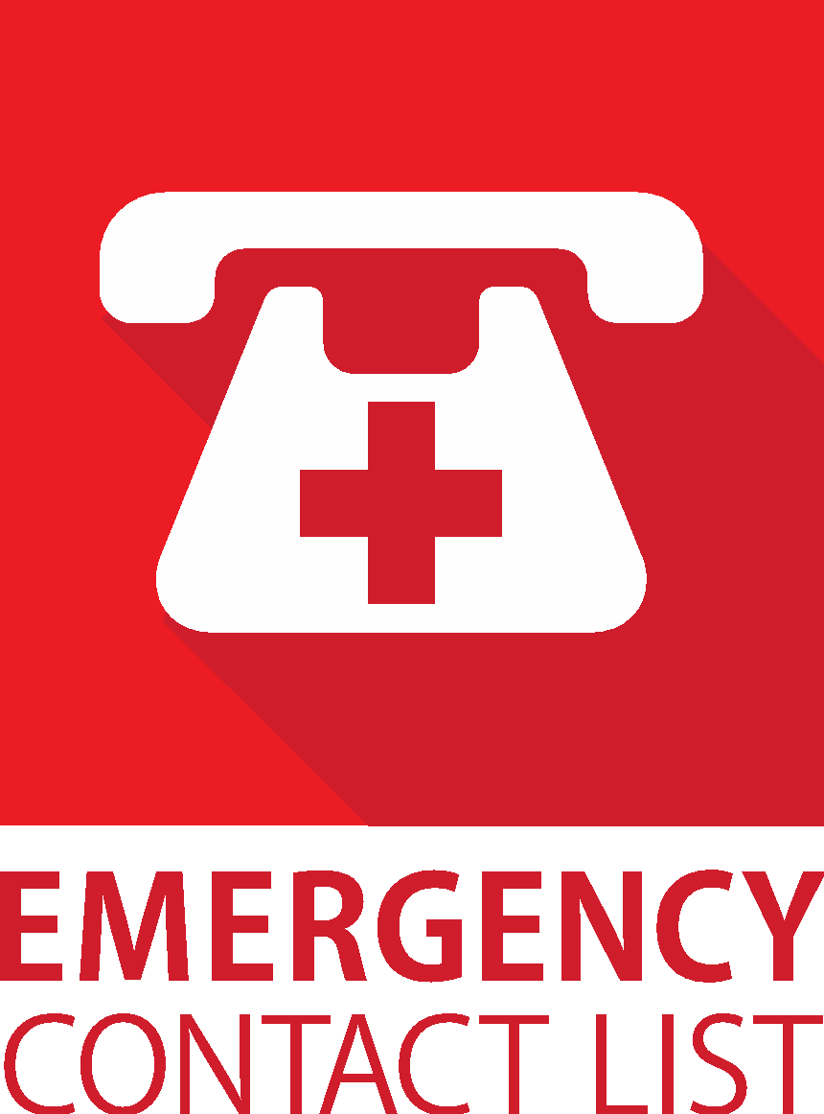
Thank you for your help in this important matter!

Sincerely,

Frederico e Camille Martins
Executive VPs
Licensed Financial Consultants
fred@fredericomartins.com

“We help you protect your family and grow your financial wealth”.

